Type of the Paper (Article, and Review, etc.)
Title
First name Last name ¹*, and First name Last name ²
¹Department of Electrical-Electronics Engineering, School of Engineering, University of Strathclyde, Glasgow, UK
²Department of Computer Engineering, College of Engineering, Karabuk University, Karabuk, Turkey

*Corresponding author: info@ijees.org

Received: Day, Month,20XX | Accepted: Day, Month,20XX | Published: Day, Month,20XX
This is an open access article under the BY-CC license

Abstract: A single paragraph of about 200 words maximum. For research articles, abstracts should give a pertinent overview of the work. We strongly encourage authors to use the following style of structured abstracts, but without headings: (1) Background: Place the question addressed in a broad context and highlight the purpose of the study; (2) Methods: briefly describe the main methods or treatments applied; (3) Results: summarize the article’s main findings; (4) Conclusions: indicate the main conclusions or interpretations. The abstract should be an objective representation of the article and it must not contain results that are not presented and substantiated in the main text and should not exaggerate the main conclusions.
Keywords: keyword 1; keyword 2; keyword 3 (List three to ten pertinent keywords specific to the article yet reasonably common within the subject discipline.)

0. How to Use This Template
The template details the sections that can be used in a manuscript. Note that each section has a corresponding style, which can be found in the “Styles” menu of Word. Sections that are not mandatory are listed as such. The section titles given are for articles. Review papers and other article types have a more flexible structure.

1. Introduction
The introduction should briefly place the study in a broad context and highlight why it is important. It should define the purpose of the work and its significance. The current state of the research field should be carefully reviewed and key publications cited. Please highlight controversial and diverging hypotheses when necessary. Finally, briefly mention the main aim of the work and highlight the principal conclusions. As far as possible, please keep the introduction comprehensible to scientists outside your particular field of research. References should be numbered in order of appearance and indicated by a numeral or numerals in square brackets—e.g., [1] or [2,3], or [4–6]. See the end of the document for further details on references.

2. Materials and Methods
The Materials and Methods should be described with sufficient details to allow others to replicate and build on the published results. Please note that the publication of your manuscript implicates that you must make all materials, data, computer code, and protocols associated with the publication available to readers. Please disclose at the submission stage any restrictions on the availability of materials or information. New methods and protocols should be described in detail while well-established methods can be briefly described and appropriately cited.
Research manuscripts reporting large datasets that are deposited in a publicly available database should specify where the data have been deposited and provide the relevant accession numbers. If the accession numbers have not yet been obtained at the time of submission, please state that they will be provided during review. They must be provided prior to publication.

3. Results
This section may be divided into subheadings. It should provide a concise and precise description of the experimental results, their interpretation, as well as the experimental conclusions that can be drawn.

3.1. Subsection

3.1.1. Subsubsection
Bulleted lists look like this:
- First bullet;
- Second bullet;
- Third bullet.
Numbered lists can be added as follows:
- First item;
- Second item;
- Third item.
The text continues here.

3.2. Figures, Tables and Schemes
All figures and tables should be cited in the main text as Figure 1, Table 1, etc.
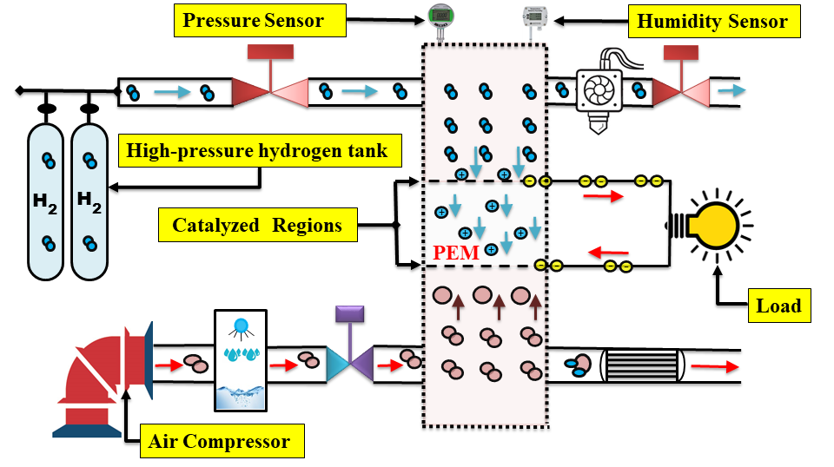
Figure 1. This is a figure. Schemes follow the same formatting.
Table 1. This is a table. Tables should be placed in the main text near the first time they are cited.
Title 1 | Title 2 | Title 3
entry 1 | data | data
entry 2 | data | data ¹
¹ Tables may have a footer.
The text continues here (Figure 2 and Table 2).
(a) | (b)
Figure 2. This is a figure. Schemes follow another format. If there are multiple panels, they should be listed as (a) Description of what is contained in the first panel; (b) Description of what is contained in the second panel. Figures should be placed in the main text near the first time they are cited.
Table 2. This is a table. Tables should be placed in the main text near to the first time they are cited.
Title 1 | Title 2 | Title 3 | Title 4
entry 1 * | data | data | data
 | data | data | data
 | data | data | data
entry 2 | data | data | data
 | data | data | data
* Tables may have a footer.

3.3. Formatting of Mathematical Components
This is example 1 of an equation:
a = 1, | (1)
the text following an equation need not be a new paragraph. Please punctuate equations as regular text.
This is example 2 of an equation:
a = b + c + d + e + f + g + h + i + j + k + + y + z | (2)
the text following an equation need not be a new paragraph. Please punctuate equations as regular text.
Theorem-type environments (including propositions, lemmas, corollaries etc.) can be formatted as follows:
Theorem 1. Example text of a theorem. Theorems, propositions, lemmas, etc. should be numbered sequentially (i.e., Proposition 2 follows Theorem 1). Examples or Remarks use the same formatting, but should be numbered separately, so a document may contain Theorem 1, Remark 1 and Example 1.
The text continues here. Proofs must be formatted as follows:
Proof of Theorem 1. Text of the proof. Note that the phrase “of Theorem 1” is optional if it is clear which theorem is being referred to. Always finish a proof with the following symbol.
The text continues here.

4. Discussion
Authors should discuss the results and how they can be interpreted from the perspective of previous studies and the working hypotheses. The findings and their implications should be discussed in the broadest context possible. Future research directions may also be highlighted.

5. Conclusions
This section is not mandatory but can be added to the manuscript if the discussion is unusually long or complex.

6. Patents
This section is not mandatory but may be added if there are patents resulting from the work reported in this manuscript.
Author Contributions: For research articles with several authors, a short paragraph specifying their individual contributions must be provided. The following statements should be used “Conceptualization, X.X. and Y.Y.; methodology, X.X.; software, X.X.; validation, X.X., Y.Y. and Z.Z.; formal analysis, X.X.; investigation, X.X.; resources, X.X.; data curation, X.X.; writing—original draft preparation, X.X.; writing—review and editing, X.X.; visualization, X.X.; supervision, X.X.; project administration, X.X.; funding acquisition, Y.Y. All authors have read and agreed to the published version of the manuscript
Funding: Please add: “This research received no external funding” or “This research was funded by NAME OF FUNDER, grant number XXX” and “The APC was funded by XXX”. Check carefully that the details given are accurate and use the standard spelling of funding agency names at https://search.crossref.org/funding. Any errors may affect your future funding.
Data Availability Statement: We encourage all authors of articles published in IJEES journals to share their research data. In this section, please provide details regarding where data supporting reported results can be found, including links to publicly archived datasets analyzed or generated during the study. Where no new data were created, or where data is unavailable due to privacy or ethical restrictions, a statement is still required.
Acknowledgments: In this section, you can acknowledge any support given that is not covered by the author contribution or funding sections. This may include administrative and technical support, or donations in kind (e.g., materials used for experiments).
Conflicts of Interest: Declare conflicts of interest or state “The authors declare no conflict of interest.” Authors must identify and declare any personal circumstances or interests that may be perceived as inappropriately influencing the representation or interpretation of reported research results. Any role of the funders in the design of the study; in the collection, analyses or interpretation of data; in the writing of the manuscript; or in the decision to publish the results must be declared in this section. If there is no role, please state “The funders had no role in the design of the study; in the collection, analyses, or interpretation of data; in the writing of the manuscript; or in the decision to publish the results”.
Appendix A
The appendix is an optional section that can contain details and data supplemental to the main text—for example, explanations of experimental details that would disrupt the flow of the main text but nonetheless remain crucial to understanding and reproducing the research shown; figures of replicates for experiments of which representative data is shown in the main text can be added here if brief, or as Supplementary data. Mathematical proofs of results not central to the paper can be added as an appendix.
Appendix B
All appendix sections must be cited in the main text. In the appendices, Figures, Tables, etc. should be labeled starting with “A”—e.g., Figure A1, Figure A2, etc.
ORCID
First name Last name https://orcid.org/0000-0000-0000-0000
First name Last name https://orcid.org/0000-0000-0000-0000
First name Last name https://orcid.org/0000-0000-0000-0000

References
References must be numbered in order of appearance in the text (including citations in tables and legends) and listed individually at the end of the manuscript. IJEES recommends preparing the references with a bibliography software package, such as EndNote, ReferenceManager or Zotero to avoid typing mistakes and duplicated references. Include the digital object identifier (DOI) for all references where available.
The template will number citations consecutively within brackets [1]. The sentence punctuation follows the bracket [2]. Refer simply to the reference number, as in [3]—do not use “Ref. [3]” or “reference [3]” except at the beginning of a sentence: “Reference [3] was the first ...”
Number footnotes separately in superscripts. Place the actual footnote at the bottom of the column in which it was cited. Do not put footnotes in the abstract or reference list. Use letters for table footnotes.
Unless there are six authors or more give all authors’ names; do not use “et al.”. Papers that have not been published, even if they have been submitted for publication, should be cited as “unpublished” [4]. Papers that have been accepted for publication should be cited as “in press” [5]. Capitalize only the first word in a paper title, except for proper nouns and element symbols.
For papers published in translation journals, please give the English citation first, followed by the original foreign-language citation [6].

- G. Eason, B. Noble, and I. N. Sneddon, “On certain integrals of Lipschitz-Hankel type involving products of Bessel functions,” Phil. Trans. Roy. Soc. London, vol. A247, pp. 529–551, April 1955. [Google Scholar]
- J. Clerk Maxwell, A Treatise on Electricity and Magnetism, 3rd ed., vol. 2. Oxford: Clarendon, 1892, pp.68–73. [Google Scholar]
- I. S. Jacobs and C. P. Bean, “Fine particles, thin films and exchange anisotropy,” in Magnetism, vol. III, G. T. Rado and H. Suhl, Eds. New York: Academic, 1963, pp. 271–350. [Google Scholar]
- K. Elissa, “Title of paper if known,” unpublished.
- R. Nicole, “Title of paper with only first word capitalized,” J. Name Stand. Abbrev., in press. [Google Scholar]
- Y. Yorozu, M. Hirano, K. Oka, and Y. Tagawa, “Electron spectroscopy studies on magneto-optical media and plastic substrate interface,” IEEE Trans. J. Magn. Japan, vol. 2, pp. 740–741, August 1987 [Digests 9th Annual Conf. Magnetics Japan, p. 301, 1982]. [Google Scholar]
- M. Young, The Technical Writer’s Handbook. Mill Valley, CA: University Science, 1989. [Google Scholar]

